**ANALYSIS OF THE GUARDIAN LEAGUE TABLE**

The purpose of this writeup is to review and analyse the criteria used by universities to determine how they are being ranked. One major question that needs to be answered is whether or not the ranking is based on the quality of the institution or the quality of the students. Another question is whether the ranking is based on the university’s reputation with other countries. This writeup will show how UWE is being compared both previously and currently with other universities in the UK. The dataset which was obtained from the National Students Survey was analysed by The Guardian league table has 12 years work of guardian data (The Guardian, 2021). Different libraries will be used to analyse the data set, such as Python, pandas and seaborn. The relevant key stakeholders who will be interested in this visualization will be identified, and lastly, some recommendations will be provided on how UWE can improve their system in order to go higher in their ranking. The screenshot shown below shows the guardian league table analysis for the UK.

Businesses do not operate in a vacuum but rather in a dynamic environment that has a direct influence on how they operate and whether they will achieve their objectives. There are external and internal business environment. The external business environment is composed of numerous outside organizations and forces that we can group into seven key sub environments: economic, political and legal, demographic, social, competitive, global, and technological.

Each of these sectors creates a unique set of challenges and opportunities for businesses and for the stakeholders that constitute the internal environments – entrepreneur, managers, workers, and customers (Brandell, 2016). In the context of the dataset adopted for this essay, therefore, the external environment of the UWE, Bristol includes the economic, political, legal, demographic, social, global, competitive, and technological factors that either make or mar the achievement of the institution. For the purpose of this writing, the global and competitive external environment are crucial. This is because the dataset speaks of the global ranking of the UWE among other competing higher institutions of learning across the world. The internal environment of the UWE represented in the dataset of this essay comprises the stakeholders, which are identified in the next subsection.

**Identify the stakeholders**

The stakeholder is the:

* Vice Chancellor
* Staff
* Students

TECHNICAL STACK(PYTHON)

• Import Libraries

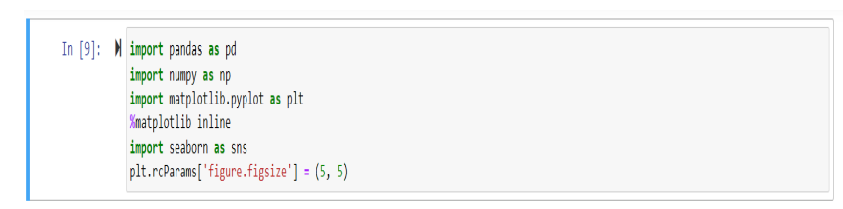

• Read data file

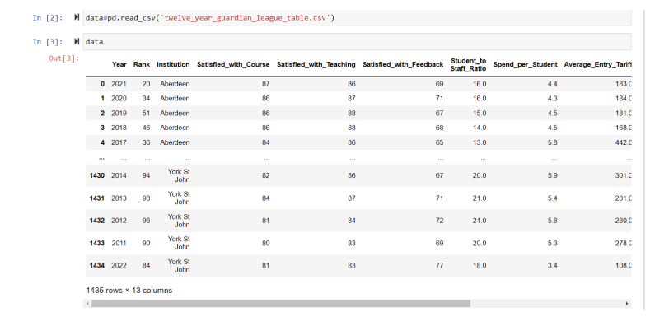

• Exploratory Data Analysis(EDA)

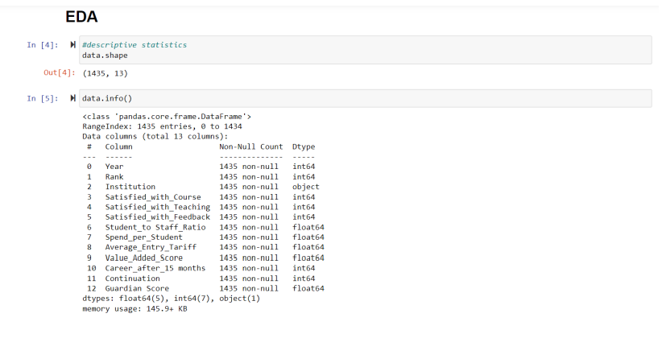

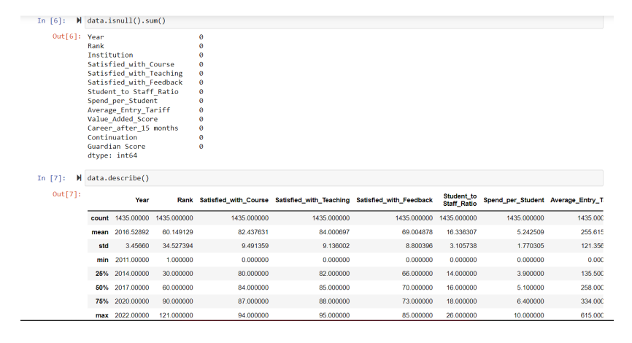

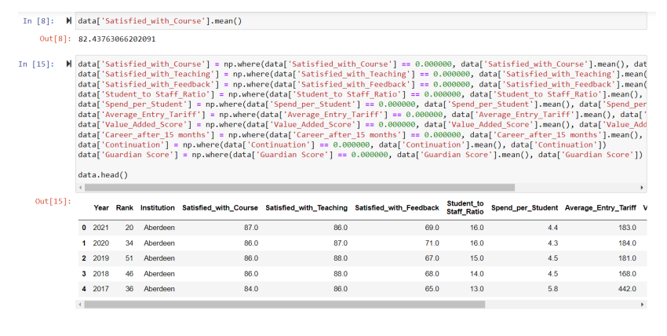

* Exploratory Graph

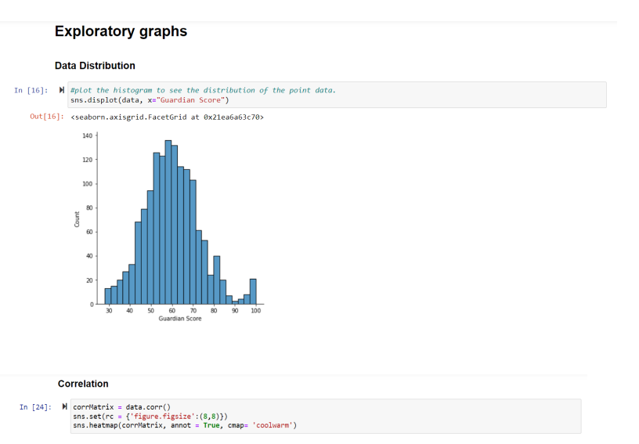

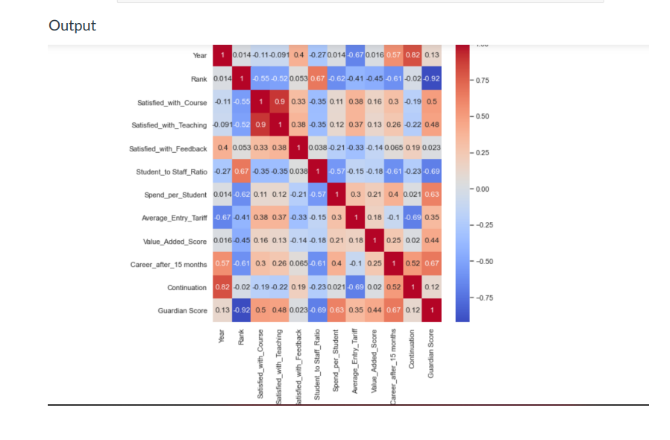

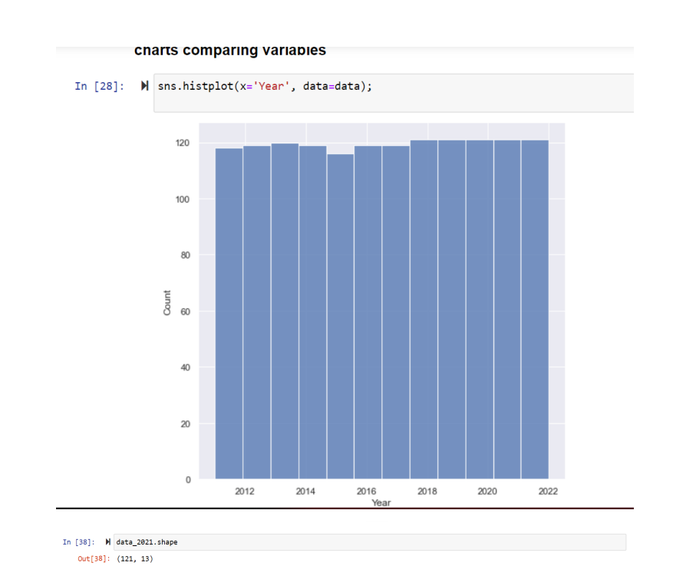

**STEPS TO FOLLOW(CODE REQUIRED)**

**-Import Libraries**

• import pandas as pd

• import numpy as np

• import matplotlib.pyplot as plt

• %matplotlib inline

• import seaborn as sns

**- Descriptive statistics**

• plt.rcParams['figure.figsize'] = (5, 5)

• data.shape • data.info()

• data.isnull().sum()

• data.describe()

• data['Satisfied_with_Course'].mean()

• #plot the histogram to see the distribution of the point data.:(sns.displot(data, x="Guardian Score"))

• Correlation

corrMatrix = data.corr()

sns.set(rc = {'figure.figsize':(8,8)})

sns.heatmap(corrMatrix, annot = True, cmap= 'coolwarm')

**- Chart comparing variable**

sns.histplot(x='Year', data=data);

**- Sorting the data into year**

#2021 Guardian Scores

data_2021 =data.loc[data['Year'] == 2021]

data_2021=data_2021.head(18)

sns.set(rc = {'figure.figsize':(20,20)})

#sns.histplot(x='Institution', y ='Guardian Score', data=data_2021);

sns.scatterplot(x='Institution', y ='Guardian Score', s= 100, palette="deep", data=data_2021);

**CONCLUSION**

In conclusion, UWE management team should conduct a review study on the strengths of the institution in 2021 when it received it highest ranking so far and the weaknesses of the institution in 2016 when it received it lowest ranking so far. The result of this review of strengths and weaknesses will enable the institution to plan adequately for future competitive ranking.

Teaching staff across all subject areas in UWE should be encouraged to embrace personal and professional development that will enhance their teaching skills and motivate students to learn their individual chosen subject to their satisfaction.

The processes of accessing the data and visualising them in line with the focus of this essay presented some challenges. Among these challenges was the rigor of visualising the data in Jupyter notebook. Since there is no scheduling option in Jupyter notebook, I must then manually refresh than automatically refresh. However, this did not so much affect the process, as I took my time to refresh manually every necessary time. Therefore, the use of Jupyter notebook for the visualisation was both rigorous and time consuming. Similarly, the use of Jupyter notebook for the visualisation also was challenging because it is not a completely open platform. In other visualization tools such as Power BI and Tableau, developers can import the visuals rather than recreating them. However, in Jupyter notebook, one must recreate the visuals rather than importing. So, it takes time to recreate.

**REFERENCES**

Brandell, B., 2016. *Business 2 Community "What is business process Management".* [Online] Available at: https://www.business2community.com, [Accessed 15 August 2022].

The Guardian, 2021. *The Guardian.* [Online] Available at: <https://www.theguardian.com/education/2021/sep/11/how-to-use-the-guardian-university-guide2022#:~:text=The%20Guardian%20score%2C%20out%20of,students%20in%20the%20latest%20NSS>. [Accessed 19 FEBRUARY 2022].

UWE Bristol , 2022. *UWE Bristol rises to 21st place in UK in Guardian University Guide 2021.* [Online] Available at: <https://info.uwe.ac.uk/news/uwenews/news.aspx?id=4066>

[Accessed 12 March 2022].